**Assignment 6 (Web Crawler)**

**Name - Chitra Paryani**

**NUID - 001869343**

Please find below screenshot of 2 implementations in MonasOps.scala and 3 implementations in WebCrawler.Scala and all test cases passed in Assignment 6 (Web Crawler):

**Implemented sequence method in MonadOps:**

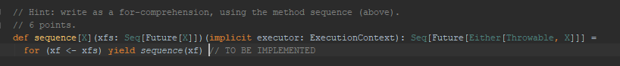

**Implemented sequence method in MonadOps:**

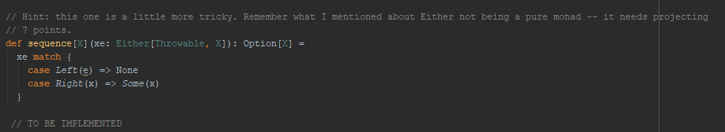

**Implemented wget method in WebCrawler.scala:**

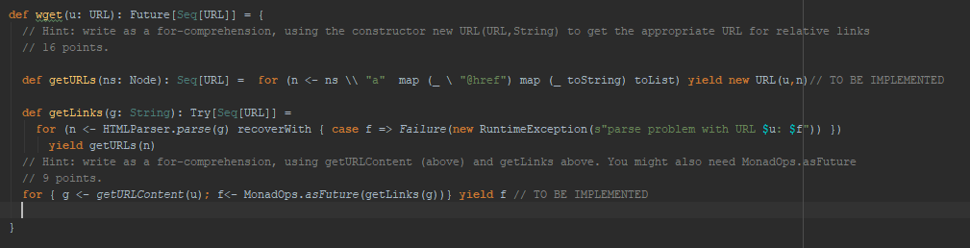

**Implemented wget method in WebCrawler.scala:**

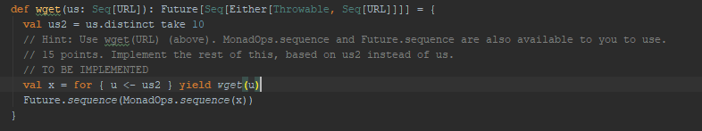

**Screenshot of test cases passed in MovieSpec.scala**

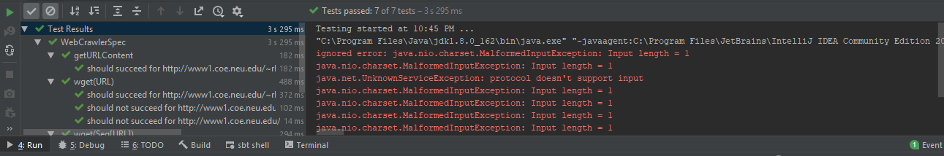

**Improvements in Web Crawler**

1. We can use actors as it will parallelize the work and improves the runtime

Below is the link I got it from internet which might help to do so:

<http://cloudmark.github.io/Crawl-In-Akka/>